**Extern Kernal 8 – REX9628 Rev. 0**

**Module Description**

# Purpose & Introduction

This project is the reverse engineering of The Extern Kernal 8 – REX Datentechnik 9628 cartridge. It serves educational purposes only. The use of this information is on own risk. It is advised not to reproduce the Extern Kernal 8 board due to possible copyright infringements.

This board is an extern kernel cartridge for the Commodore C64. It allows to switch between up do 8 Kernals (operating systems) stores in two 27C256 EPROMs.

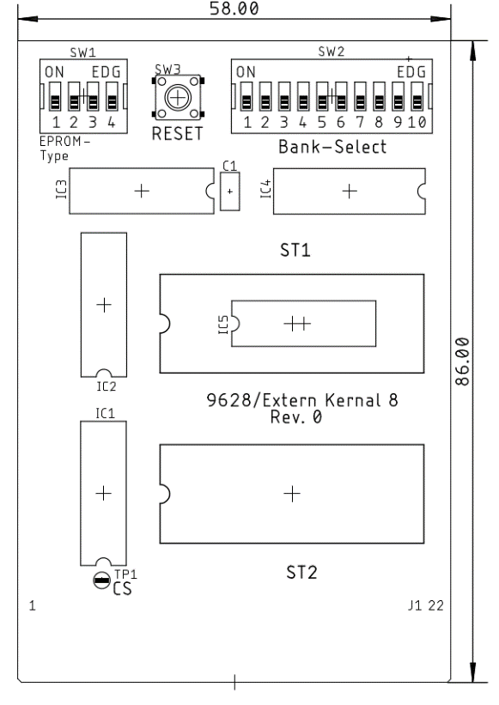

Figure 1: Layout of the Extern Kernal 8 including measures

It is possible to combine different types of EPROMs (27C256, 27C128 and 27C64), which have different memory sizes. This memory size determines the number of kernals, that are stored in such an EPROM.

Extern Kernal 8 is not suitable for storing (game) firmware, which is intended to be used with a generic 8k or 16k cartridge, like games etc.

The kernals are mapped to the C64 address space between 0xE000 and 0xFFFF. One signal, that is used to access the RAM in the same area () is not mapped to the expansion port, so software, that is requiring this part of the RAM will conflict with the Kernal cartridge. A possible solution is to connect this internal signal to the solder pad TP1 (“CS”).

# Configuration

The purpose of DIP-switch **SW1** to set the combination of EPROM types.

| 1 | 2 | 3 | 4 | ST1 | ST2 |
| --- | --- | --- | --- | --- | --- |
| on | off | on | off | 2764 | 2764 |
| on | off | on | off | 27128 | 28128 |
| off | on | off | on | 27256 | 27256 |
| on | off | off | on | 2764/27128 | 27256 |
| off | on | on | off | 27256 | 2764/27128 |

DIP-switch **SW2** selects the kernal

|  |  |  |  |  |  |  |  |  |  |
| --- | --- | --- | --- | --- | --- | --- | --- | --- | --- |
| 1 | 2 | 3 | 4 | 5 | 6 | 7 | 8 | EPROM | Addr. Offset |
| on | off | off | off | off | off | off | off | ST1 | 0x0000 |
| x | on | off | off | off | off | off | off | ST1 | 0x2000 |
| x | x | on | off | off | off | off | off | ST1 | 0x4000 |
| x | x | x | on | off | off | off | off | ST1 | 0x6000 |
| x | x | x | x | on | off | off | off | ST2 | 0x0000 |
| x | x | x | x | x | on | off | off | ST2 | 0x2000 |
| x | x | x | x | x | x | on | off | ST2 | 0x4000 |
| x | x | x | x | x | x | x | on | ST2 | 0x6000 |

x: do not care

A 27C128 can hold up to two kernals, a 27C64 is only capable of one.

When inserting the EPROMs into the socket, make sure, that the notch of the socket and of the IC are adjusted and that all pins of the IC insert properly into the socket.

Switch SW2-9 provides a game stop function. SW2-10 can activate or deactivate the cartridge.

|  |  |  |  |
| --- | --- | --- | --- |
| **Mode Select** | | **Position** | |
| **Switch** | **Function** | **off** | **on** |
| SW2-9 | Game Stop | normal | stop |
| SW2-10 | Cartridge on/off | off | on |

It is strictly advised to configure the cartridge while power off. Changing the settings while the C64 is running will usually cause system crashes.

SW3 acts as a reset switch.